**Exercise 3.2**

**Step 2. Extract the ERD:**

* Extract the ERD from the Rockbuster database and save it as an image (PNG or JPEG) using the instructions in the Exercise.
* 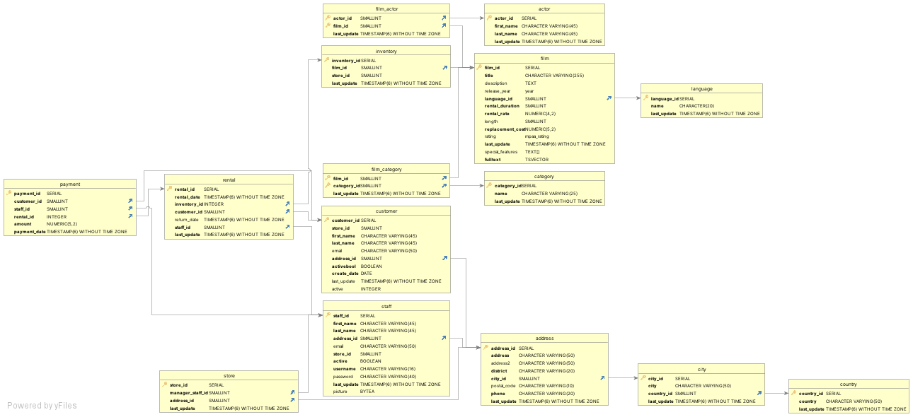Copy-paste the ERD into your answers document.

**Step 3. Create the first draft of a data dictionary:**

* **Take a moment to examine your ERD. Does the Rockbuster database have a snowflake schema or a star schema? Write a brief explanation for your answer.**
  + Star Schema - the central fact table is surrounded by dimension tables, which are surrounded by sub-dimension tables, so it should be classified as a star schema.
* **List all the fact tables and all the dimension tables in the schema. For each table, list every column and its data type, and write a brief description of the column.**

**Fact Tables:**

* **Payment**

|  |  |  |
| --- | --- | --- |
| **Column** | **Data Type** | **Description** |
| payment_id | SERIAL | unique identifier of a payment |
| customer_id | SMALLINT | unique identifier of a customer |
| staff_id | SMALLINT | unique identifier of a staff member |
| rental_id | INTEGER | unique identifier of a rental |
| amount | NUMERIC (5,2) | price of a rental |
| payment_date | TIMESTAMP (6) WITHOUT TIME ZONE | date of payment |

* **Rental**

|  |  |  |
| --- | --- | --- |
| **Column** | **Data Type** | **Description** |
| rental_id | SERIAL | unique identifier for each rental |
| rental_date | TIMESTAMP (6) WITHOUT TIME ZONE | date of rental transaction |
| inventory_id | INTEGER | unique identifier for inventory |
| customer_id | SMALLINT | unique identifier for a customer |
| return_date | TIMESTAMP (6) WITHOUT TIME ZONE | Item “to be returned by” date |
| staff_id | SMALLINT | unique identifier for staff |
| last_update | TIMESTAMP (6) WITHOUT TIME ZONE | date of last update |

**Dimension Tables:**

* **Store**

|  |  |  |
| --- | --- | --- |
| **Column** | **Data Type** | **Description** |
| store_id | SERIAL | unique identifier for a store |
| manager_staff_id | SMALLINT | unique identifier for a staff manager |
| address_id | SMALLINT | address of the store |
| last_update | TIMESTAMP (6) WITHOUT TIME ZONE | date of last update |

* **Film Actor**

|  |  |  |
| --- | --- | --- |
| **Column** | **Data Type** | **Description** |
| actor_id | SMALLINT | unique identifier for an actor |
| film_id | SMALLINT | unique identifier for a film |
| last_update | TIMESTAMP (6) WITHOUT TIME ZONE | date of last update |

* **Inventory**

|  |  |  |
| --- | --- | --- |
| **Column** | **Data Type** | **Description** |
| inventory_id | SERIAL | unique identifier for inventory |
| film_id | SMALLINT | unique identifier for a film |
| store_id | SMALLINT | unique identifier for a store |
| last_update | TIMESTAMP (6) WITHOUT TIME ZONE | date of last update |

* **Film Category**

|  |  |  |
| --- | --- | --- |
| **Column** | **Data Type** | **Description** |
| film_id | SMALLINT | unique identifier for a film |
| category_id | SMALLINT | unique identifier for a category |
| last_update | TIMESTAMP (6) WITHOUT TIME ZONE | date of last update |

* **Customer**

|  |  |  |
| --- | --- | --- |
| **Column** | **Data Type** | **Description** |
| customer_id | SERIAL | unique identifier for a customer |
| store_id | SMALLINT | unique identifier for the store |
| first_name | CHARACTER VARYING(45) | first name of customer |
| last_name | CHARACTER VARYING(45) | last name of customer |
| email | CHARACTER VARYING(50) | email of customer |
| address_id | SMALLINT | address of customer |
| activebool | BOOLEAN | active or not |
| create_date | DATE | date customer was created in the system |
| last_update | TIMESTAMP (6) WITHOUT TIME ZONE | date of last update |
| active | INTEGER | active or not |

* **Staff**

|  |  |  |
| --- | --- | --- |
| **Column** | **Data Type** | **Description** |
| staff_id | SERIAL | unique identifier for a staff member |
| first_name | CHARACTER VARYING(45) | staff member’s first name |
| last_name | CHARACTER VARYING(45) | staff member’s last name |
| address_id | SMALLINT | staff member’s address |
| email | CHARACTER VARYING(50) | staff member’s email |
| store_id | SMALLINT | unique identifier for a store |
| active | BOOLEAN | active or not |
| username | CHARACTER VARYING(16) | staff member’s username |
| password | CHARACTER VARYING(40) | staff member’s password |
| last_update | TIMESTAMP (6) WITHOUT TIME ZONE | date of last update |
| picture | BYTEA | photo of the staff member |

* **Actor**

|  |  |  |
| --- | --- | --- |
| **Column** | **Data Type** | **Description** |
| actor_id | SERIAL | unique identifier for an actor |
| first_name | CHARACTER VARYING(45) | actor’s first name |
| last_name | CHARACTER VARYING(45) | actor’s last name |
| last_update | TIMESTAMP (6) WITHOUT TIME ZONE | date of last update |

* **Film**

|  |  |  |
| --- | --- | --- |
| **Column** | **Data Type** | **Description** |
| film_id | SERIAL | unique identifier for a film |
| title | CHARACTER VARYING(255) | title of film |
| description | TEXT | description of film |
| release_year | year | year the film was released |
| language_id | SMALLINT | unique identifier for the language the film is in |
| rental_duration | SMALLINT | how long the film has been rented |
| rental_rate | NUMBERIC(4,2) | rate of rental |
| length | SMALLINT | length of film |
| replacement_cost | NUMBERIC(5,2) | cost to replace rental film |
| rating | mpaa_rating | Motion picture association film rating, or what age groups the movie is appropriate for |
| last_update | TIMESTAMP (6) WITHOUT TIME ZONE | date of last update |
| special_features | TEXT [] | film special features |
| fulltext | TSVECTOR | text of film |

* **Category**

|  |  |  |
| --- | --- | --- |
| **Column** | **Data Type** | **Description** |
| category_id | SERIAL | unique identifier for a category |
| name | CHARACTER VARYING(25) | name of category |
| last_update | TIMESTAMP (6) WITHOUT TIME ZONE | date of last update |

* **Address**

|  |  |  |
| --- | --- | --- |
| **Column** | **Data Type** | **Description** |
| address_id | SERIAL | unique identifier for an address |
| address | CHARACTER VARYING(50) | address |
| address2 | CHARACTER VARYING(50) | additional address details |
| district | CHARACTER VARYING(20) | name of district |
| city_id | SMALLINT | unique identifier of a city |
| postal_code | CHARACTER VARYING(10) | postal code details |
| phone | CHARACTER VARYING(20) | phone number |
| last_update | TIMESTAMP (6) WITHOUT TIME ZONE | date of last update |

* **Language**

|  |  |  |
| --- | --- | --- |
| **Column** | **Data Type** | **Description** |
| language_id | SERIAL | unique identifier for a language |
| name | CHARACTER(20) | name of the language |
| last_update | TIMESTAMP (6) WITHOUT TIME ZONE | date of last update |

* **City**

|  |  |  |
| --- | --- | --- |
| **Column** | **Data Type** | **Description** |
| city_id | SERIAL | unique identifier for a city |
| city | CHARACTER VARYING(50) | name of the city |
| country_id | SMALLINT | unique identifier for a country |
| last_update | TIMESTAMP (6) WITHOUT TIME ZONE | date of last update |

* **Country**

|  |  |  |
| --- | --- | --- |
| **Column** | **Data Type** | **Description** |
| country_id | SERIAL | unique identifier for a country |
| country | CHARACTER VARYING(50) | name of country |
| last_update | TIMESTAMP (6) WITHOUT TIME ZONE | date of last update |

**Step 4. Find information:**

**Now that your data dictionary and ERD are ready to use, your manager has given you a list of business questions to answer. Use your data dictionary to figure out which tables you’d need to answer the questions below:**

* **Which actors brought Rockbuster the most revenue?**
  + Payment - Rental - Inventory - Film_actor – Actor
* **What language are the majority of movies in the collection?**
  + Inventory – Film - Language